Top Movies by Production Budget Analysis

Kevin Thomas

I will be analyzing a dataset that contains the top 500 movies by production budget that also includes box office gross, net earnings, year, and movie rating. For the dataset 25 movies had to be removed due to missing values. I will try to find what makes a high budget film successful.

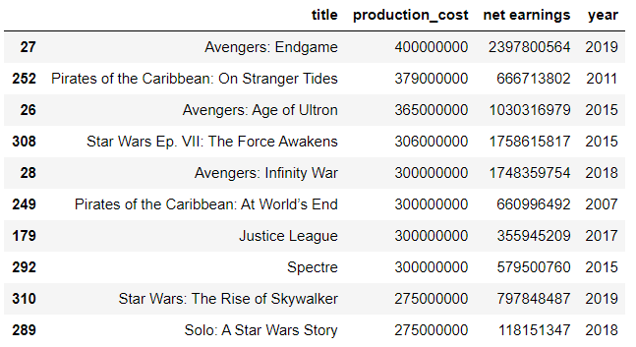

The first analysis I did was to see which movies had the highest production cost and show their net earnings. Each movie had positive net earnings. Justice League was ranked 7th but net earnings were sufficiently lower than the other movies' net earnings. Same can be said for Solo: A Star Wars Story

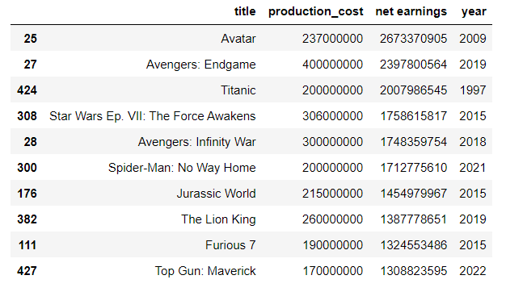

I now sorted the movies by highest net earnings also showing their production cost. Only 3 of the movies that were shown with the highest production cost were featured in this list.

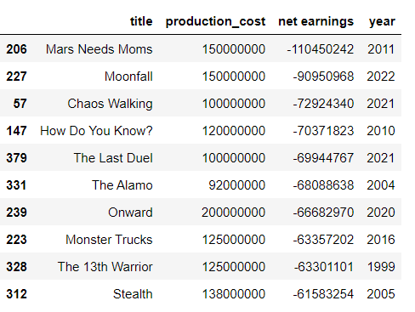

These are movies that had the lowest net earnings. All these movies have low production costs compared to the highest production costs.

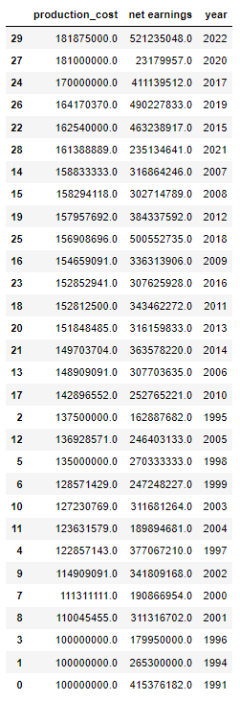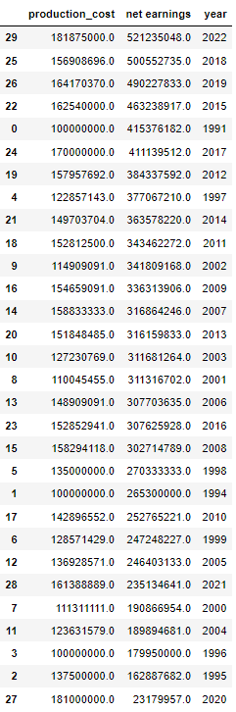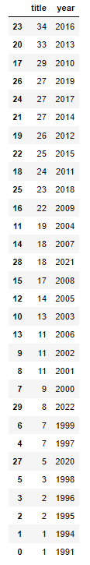

I reviewed the dataset by year. The first one indicates the total average production cost by year and the second table indicates the total average net earnings by year. I also included the movie count by year as some years only have one movie produced. 2020 had only 5 movies produced but had the second highest average production cost. 2020 also ended up having the lowest net earnings. This happened because COVID-19 occurred during this time and movie theaters were shut down.

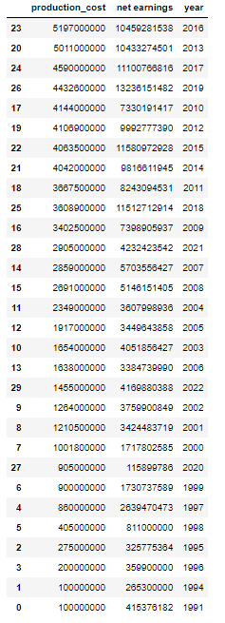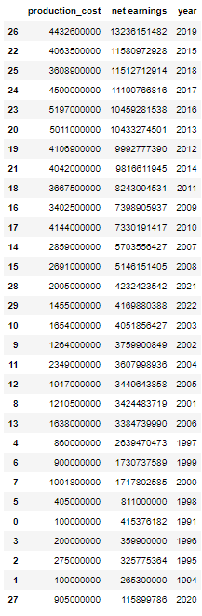

I used the same data, but I sorted it by total production cost and net earnings. 2016 had the highest production cost but finished 5th in total net earnings. 2016 also had the movies produced with 34. 2019 finished with the highest net earnings despite being 4th in total production cost.

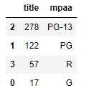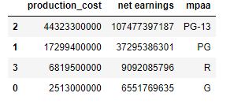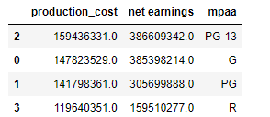

This 3rd graph indicated the average production cost and net earnings.

I used the data to sort the movies by rating. PG-13 had the most movies produced with 278. G had the lowest movie produced with 17 despite this G was close to the same average net earnings as PG-13. 57 R movies were produced but the average was significantly lower than the other ratings. This happened because rated R movies require an adult guardian to accompany people under 17.

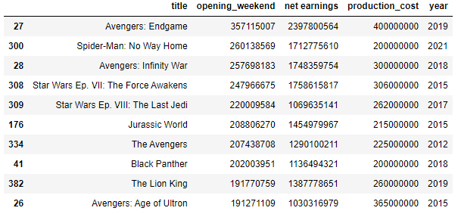

These are the movies with the highest opening weekend. All but one (Jurassic World) was made by a Disney-owned studio.

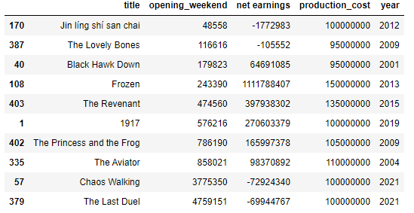

These are movies with the lowest opening weekend. 4 of these movies with negative net earnings. Frozen had the 4th lowest opening weekend, despite this it was able to surpass 1 billion dollars in net earnings. Frozen even ended up having higher net earnings than Avengers: Age of Ultron which was 10th in highest opening weekend. Avengers: Age of Ultron did significantly have higher production costs than Frozen though.

The average production cost of a movie was $149,694,515. 224 movies were produced above the average while 250 movies were produced below the average. The average net earnings of a movie were $338,431,728. 181 movies were able to earn above the net earnings average while 293 movies earn below the net earnings average.

This double line graph indicates the production cost vs net earnings over the years. Blue indicates the net earnings while red indicates the production cost. From this data, you can see from years 2010-2019, there was massive profit made from movies. 2020 was really the only year where there was a lost of profit made.

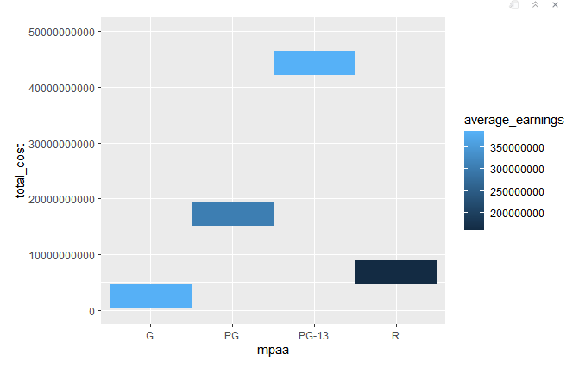

This heat map indicates the total production cost and average net earnings by rating. This graph shows that even though PG-13 movies were produced significantly more than G movies, they still netted the same average earnings.

This bar graph indicates the average net earnings by genre. This graph shows that action, adventure, and musicals get the highest net earnings, while romantic comedies tend to fail when released.

**Conclusion**

I was able to make multiple conclusions based on the dataset. 2010-2019 were the years where high budget films were being produced and making positive net earnings the most. Disney produced movies tend to do well in the box office and be profitable. Making a highly produced rated R film won’t be as profitable as the other ratings. Action, Adventure, and Thriller were the most common genres that were most profitable. 2020 was a tough year for movies as the COVID-19 pandemic was occurring but it is looking like its going to bounce back for later years to come.